Computer Technology
Technology Operations and Concepts

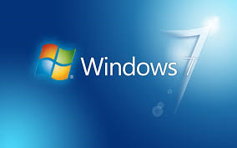

FILE MANAGEMENT & SHORTCUTS ACTIVITY
(S1 Obj 3-2)

IDENTIFYING SYSTEM SETTINGS & INSTALLING/REMOVING SOFTWARE
(S1 Obj 3-4)

Completed | Assignments | Points | Earned
 | File Management Screens Shots Activity | 20
 | Creating Shortcuts Screen shot Activity | 20
 | Changing System Settings & Installing/Removing Software Screen Shot Activity | 20
 | TOTAL | 60

Note to teachers: These activities could be included in a Computer Basics unit when MS Windows is being introduced.

