IDENTIFYING SYSTEM SETTINGS & INSTALLING/REMOVING SOFTWARE
Technology Operations & Concepts (S1 Obj 3-4)
Computer Tech

Part A – Identifying How to Change System Settings: Using the Control Panel and the Appearance and Personalization options, make the following changes to the display on your Windows 7 settings.

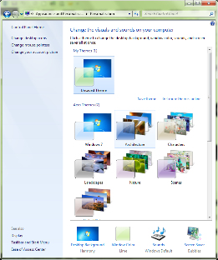
- Open the Appearance and Personalization options in the Control Panel by using the following patU: Start Menu>Control Panel (on the right)>Appearance and Personalization.

- First, select “Change the theme” and select a new theme.

- Second, make a change to your desktop background by clicking on “Desktop Background” at the bottom of your screen.
You may also make changes to your window color and to your screen saver. Save your changes.
- Take a screen shot of your new desktop background, paste and size it to fit on the top half of the page in a new MS Word document. Save it as System Settings & Software using the following path U: U:/>Computer Tech folder>Comp Basics folder. Leave this file open for Part B. (Screenshot for grade)

Part B –Installing & Removing Software: Using Google Search and the Control Panel from the Start Menu, install Google Earth and then uninstall the same program from your computer.

- In Google, search for “Google Earth”. Click the link for Google.com/earth/download/

- Click the “Download Google” bar.

- Remove the checks in the Google Chrome information boxes at the top of the screen.

- Review/read the terms of Services agreement and hit “I agree.”

- Read the prompt under “Thank you” and click the link if the download does not start within a short period of time.
- Answer “Run” when the next prompt appears and “yes” to allow on the next prompt.

- Use the Windows key + D to get back to your desktop. Look for the Google Earth icon. Click on the icon on your desktop and try it out.

- Go back to your desktop and take a screen shot of your desktop background showing the new Google Earth icon. Paste and size it to fit on the bottom half of the page in your System Settings & Software file. Save again using Save As and name it Period #, Last name, First name, System Settings & Software and submit according to your teacher’s instructions.
(Screen check for grade.)

- Uninstall Google Earth by going to the Start Menu>Control Panel>Programs>Uninstall a program.

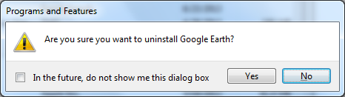
- Choose Google Earth from the list and double click. Answer “Yes’ to the prompt and yes again to the next system prompt that comes up.

- Go back to your desktop (Hint: Windows + D) and make sure the icon is no longer on your desktop.

- Congratulations you have learned how to change settings on your computer, install and uninstall software on your computer.

