Computer Applications
PowerPoint Unit 2 Concepts (Tutorial 2)
Slide Layouts/Formatting
Review pages with diagrams first!
PPT 64-65 & PPT 84-85
- Change the layout (two content, title slide, blank)
- Delete a placeholder
- Format font size, color, alignment
Shapes/Graphics
- Insert shapes
- Apply styles to shapes
- Insert pictures
- Insert clip art
- Insert SmartArt
  - Convert text to SmartArt (green button)
  - Apply styles (bevel, 3D, etc.)
  - Add a shape to a SmartArt diagram (Design, Add Shape)
- Add text to a shape (right click, Add/Edit Text)
- Add text box
- Add a border to a picture; set width and color
- Apply a style to a picture
- Apply an effect to an image
- Align objects on a slide (Drawing Tools, Format)
- Rotate an object (Format, Arrange)
- Crop an image
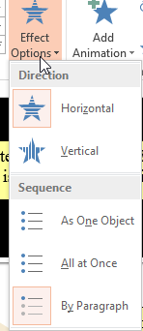
- Recolor a picture (temperature, saturation, tint)
- Resize, set height on images/shapes
  - Drag from corner to maintain “aspect ratio” (not smash/stretch)
- Flip/mirror an object vertically/horizontally
- Change fill color of a shape
- Select multiple objects (Shift+click; often used to then Align or Group)
Animation
- Apply animation effect to a shape
- Customize direction and speed of an animation (Effect Options)
Slide Show
- Modify slide master
- Broadcast slide show over the internet
Computer Applications Assignments
- Complete the Review Assignment, LandTour.pptx PPT110-111
  - Check with the binder keys
- SAM Project PPT Unit 2 Case Study 1 (graded by computer)

