Computer Technology
Technology Operations and Concepts
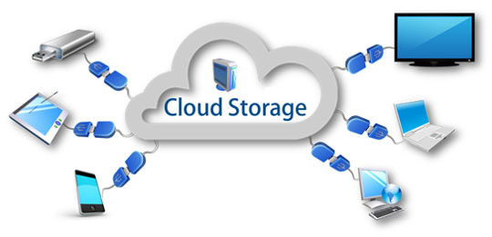

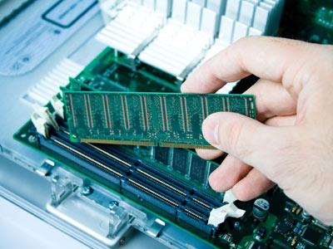

Unit 3 Grade Sheet
Memory & Storage
Part A = (S1 Obj 2-3)
Part B = (S1 Obj 2-3 and S3 Obj 1-1)

Completed | Assignments | Points | Earned
 | Unit 3—Part A Memory Listening Guide | 40
 | Unit 3—Part B Storage Listening Guide | 20
 | Unit 3—Memory and Storage Assignment  Save as: lastname firstname memory  Submit to Dropbox | 50
 | Unit 3—Memory and Storage Test Review | 20
 | TOTAL | 130

Test Review Games:
Quia Test Review Game 1 http://www.quia.com/hm/814359.html
Quia Test Review Game 2 http://www.quia.com/rd/272305.html
Quizlet Flash Cards & Test Review Games http://quizlet.com/_7qo02

Technology Operations and Concepts
Unit 3 Examview Test:
Date: _____________________________________

Unit 3—Part A: Memory
Listening Guide
- Define memory. _______________________________________
_____________________________________________________
- RAM stands for _____________________________________________.
- RAM is the memory that holds data as you ________________________.
- RAM is volatile. What does Volatile mean? _______________________
- Many people add __________________________ to their computers to improve performance when their computer is sluggish.
- ROM stands for ________________________________________________________________.
- ROM contains the instructions the computer uses when it ______________________________.
- ROM is non-volatile. What does non-volatile mean? ___________________________________
- Define Binary Code. _____________________________________________________________
______________________________________________________________________________
- Binary Code uses just two digits ______ & ______.
- Each 0 or 1 is called a __________.
- A combination of eight bits is called a _______________.
- One byte represents ____________________________________________________________.
- Kilobyte (KB) = Approximately ________________________________________.
- Megabyte (MB) = Approximately ______________________________________.
- Gigabyte (GB) = Approximately _______________________________________.
- Terabyte (TB) = Approximately _______________________________________.
- Approximately how many magazine pages (5000 characters per page) would it take to fill one Terabyte of disk space? ___________________________
- Petabyte (PB) = Approximately ______________________________________.
- Exabyte (EB) = Approximately _______________________________________.

Unit 3—Part B: Storage
Listening Guide
- Define Storage.

- What are four popular storage devices used today.
  - c.
  - d.
- List the three kinds of storage

- Define Magnetic Storage.

- List three storage devices that use magnetic storage.
___________________ _________________________ _________________________
- A hard drive is a mass storage device located _____________________________________.
- An external hard drive has its own separate case and sits ___________________________.
- Floppy disks are becoming obsolete, which means _________________________________________________________________________.
- What are magnetic tapes used for?

- Define Optical Storage.

- CDs are used to _____________________________________________________________.
- CD storage capacity is from _____________________ to ____________________________.
- DVDs are used to ____________________________________________________________.
- DVD storage capacity is from ___________________ to_____________________________.
- How many times can you burn data to a CD-ROM or DVD-ROM? ______________________
- How many times can you burn data to a CD-R or DVD-R? ____________________________
- How many times can you burn data to a CD-RW or DVD-RW? ________________________
- Which types of CD and DVD can you reformat, erase and rewrite data to? ______________
- Define Electronic Storage.

- List 3 storage devices that use Electronic Storage.
__________________________ _______________________ _____________________
- Why is Electronic Storage faster?

- Define Flash Drive.

- Flash Drives can store anywhere from ___________________________ to _____________.

- Memory cards are used to store data in ________________________________________________________________________.
- Memory cards store anywhere from ________________________ up to _______________.

- Write a paragraph discussing the difference between solid state drives and hard disk drives discussed in the video on slide 14.

- What does SSD stand for? ______________________________________________________

- Solid state drives store data via electronic semiconductors that are built from solid materials and have no ____________________________________.

- What are the advantages of an SSD drive over a hard drive?

- What are two disadvantages of using an SSD drive over a hard drive?

- When something is in the cloud, it means it is stored on __________________________ instead of on _________________________________________.

- Cloud based applications are called _______ _________ and run inside your Internet browser.

- With your photos and other multi-media stored in the cloud, you will never have to worry about _____________________________________________________________________.

- You can use cloud based services like ________________________ or ______________________ to back up the contents of your computer.

- What are 2 things the cloud has to offer you? _____________________________________
__________________________________________________________________________

- What does SaaS stand for? ____________________________________________________

- With SaaS, software is not installed on your computer, instead it is installed on _____________________________________ and you pay to _________________ the software via the ______________________________.

- Using the cloud allows companies to pay for ___________________ rather than ______________________ and _____________________ to service them.

- What are two reasons you should use the cloud?
___________________________________________________________________________

- Write 2-3 sentences discussing Cloud Computing Security.

